**SIPP COORDINATOR INTERNSHIP MONITORING AND INTERN E-PORTFOLIO WEB APP**

**Introduction**

In our life today, technology is one of many inventions that greatly affect our way of living. In fact, it is noted as an essential tool in many areas including business, government, industry, sciences, education, school, home, and in almost any company and establishment that existed. It can perform process data rapidly, accurately and reliable and by using these technologies, spending a lot of time and effort in doing a certain task is minimized.

Technology nowadays has become the most needs of data and information processing. Technologies have been very effective in many fields of work and study. It certainly helps man to make his task much easier and with great precision. Computer programmers now a day try to build and develop high-quality systems that are very useful. In this generation, we are still expecting more and still looking forward for a better versions of system to take place in people’s manual work with regards of this matter, through the long search of system that can help the institution, the computer programmer gained and came up with a very useful system. A SIPP coordinator internship monitoring and E-portfolio web app. This system is developed and design to help the SIPP coordinator and the student to enhance and develop its general information.

SIPP coordinator internship monitoring and E-portfolio web app aimed to automate the monitoring of on-the-job trainee and to automate processing of portfolios. It will be utilize to monitor the precise records of hours rendered by the trainee and to monitor the trainees in their respective facilities where they currently working. Also, all sorts of reports, announcements, and updates will be done through the system. In the manual and traditional way of record keeping and monitoring there are some adversities that can’t be avoided like losing some records of the trainees and barriers between the interaction of trainees and the coordinator. The proposed system will eliminate the possibility of these errors to occur. All records of the trainee will be keep and manage using the system.

The purpose of this system is to alleviate or reduce the problems regarding the monitoring of the trainee and implement the electronic portfolio for the trainee. This system is to improve the supervision of trainees and also includes monitoring their attendance and assisting SIPP coordinator to facilitate their manual paper works. Develop a system to help staff and make it easy to track their attendance and their work without much effort.

With the system, providing a user-friendly environment and effective performance system, it will provide easier and faster access to the data of each student and teacher in their Admission Report.

Problem statement

* The monitoring of trainees information are entered and stored manually in papers or books which is prone to loss of files.
* The manual method of monitoring intern is extremely complex to manage and record keeping requires physical storage.
* Attendance in log book can lead to errors, tampering and fraud.
* Every trainees are required to comply their work documentation in portfolio but in processing of their portfolio is manual where they write or encode their documentation and print it and it takes so much time and efforts and cost a lot of money.
* Processing portfolio requires a lot of papers

Objectives:

The SIPP COORDINATOR INTERNSHIP MONITORING AND INTERN E-PORTFOLIO WEB APP aims to:

1. To provide SIPP Coordinator to Automate their manual work in entering, recording and storing their trainees’ data or Information during the training period.
2. To help SIPP Coordinators create internship plan and reports. And create important announcement.
3. To provide automated recording of trainees’ attendance.
4. To provide trainees Electronic portfolio
5. To provide trainees complaint message section that will direct to admin.

FUNCTIONAL REQUIREMENTS

* The System require the user to login into the system.
* Admin login –The administrator must Log-in in their username and password to access the function of all the system from adding, editing to deleting the data. The SIPP coordinator is the Authorized person to access the system to view the data record in the system and for the safety and security of the student.
* Trainee login - user must log in in his/her username and password to access the system. The On the job trainee (OJT) is the Authorize person that can access the trainees dashboard for their security.
* The System display the function bar in the dashboard
* The System records trainees information and attendance
* The trainee need to click the button “Time in” And when they log out the trainee will click the button “Time out”. The system will automatically record his/her attendance of their time in/out. And trainee is mandated to upload a picture every day upon entering into the establishment or facility where he/she is currently training as a proof that he/she is really in the work field.
* The system will notify the admin for those trainee who are already entered in their field.
* The system will allow the admin to view the trainees information
* The system automatically compute the trainees rendered hours and will automatically notify if the trainee already comply the hours in their training.
* When the SIPP coordinator create an important announcement the system will automatically notify the trainees.
* In processing the portfolio, the system provide the form and the trainee will fill up the form. Then after complying the form the trainee will click the “submit” button then the system will record the document and the system will convert the file into pdf but still editable only by trainee and the system will allow the SIPP coordinator to read the pdf file of the portfolio.

**USER INTERFACE**

**Admin Dashboard –**the Home serves as the homepage of the administrator. The dashboard displays the following information:

* List – list of students under training in a specific day of a specific month with the record of hours they rendered.
* Date
* Time

The image below is the design of the Admin Dashboard

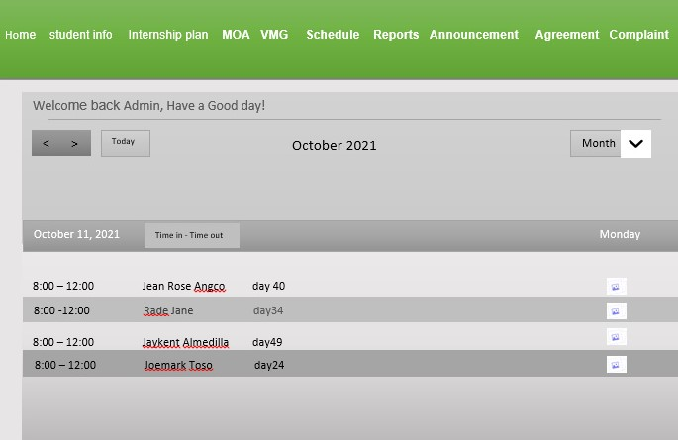

**Student Dashboard** – the Home serves as the homepage of the students or trainees after logging in the system. The dashboard displays the following information:

* Name of the Student
* Date – the current date when the student use the system
* Time – current time when the student use the system
* Duration
* Total Rendered Time – the total hours spend by the trainee during a specific day
* Time in and out button
* Upload Button
* List – list of days the trainee did the training and for how many hours.
* Shown below is the image of the student dashboard design.

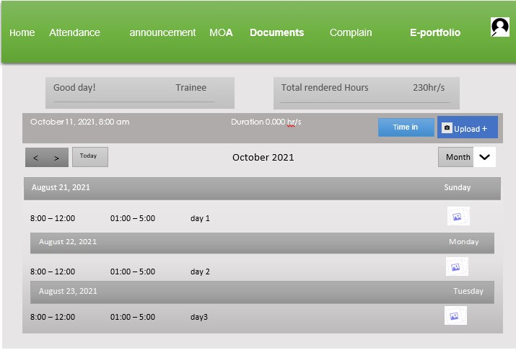

Good Day! Jean Rose Angco